User Stories:

Whether I am an admin, Manager, or customer I should be able to change my password and name.

As an admin, I should be able to add a new user to the system in the customers tab

As an admin, I should be able to change the authentication of any user in the case of a promotion/demotion.

As a manager, I should be able to add new products and edit existing ones in the product tab.

As a manager, I want to login and be able to view a summary report of sales from the system when I hit print receipt.

As a cashier, I want to add a new customer or update a current customer in the system.

As a cashier, I want to add a new purchase or update a current purchase (only price and quantity) in the system.

As a customer, I want to add a new purchase into the system through the purchases tab.

As a customer, I want to view my purchase history into the system and shouldn’t be able to see other purchases that are not mine.

As a customer, I want to search for product information (based on name, price) in the system while in the products tab.

## ADMIN USER STORIES ##

User Story: Whether I am an admin, Manager, or customer I should be able to change my password and name.(UserID 1, Jones Fuller, pass, changes his info to Jones Fulle**n** and changes his password to “password” **NOTE: all users have this ability**)

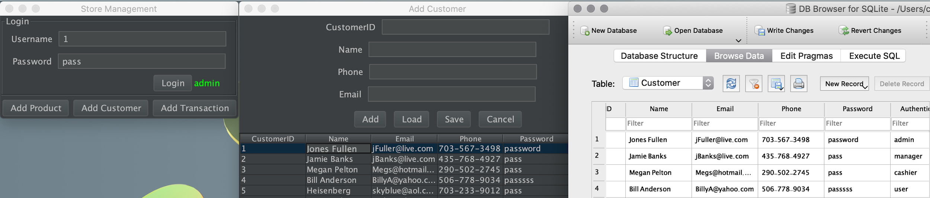

- As an admin, I should be able to add a new user to the system in the customers tab.(Here, new user with ID 13, name Example, phone 123-456-7890, and email [example@live.com](mailto:example@live.com) is added, password and Auth is automatically generated and can be edited afterwards)

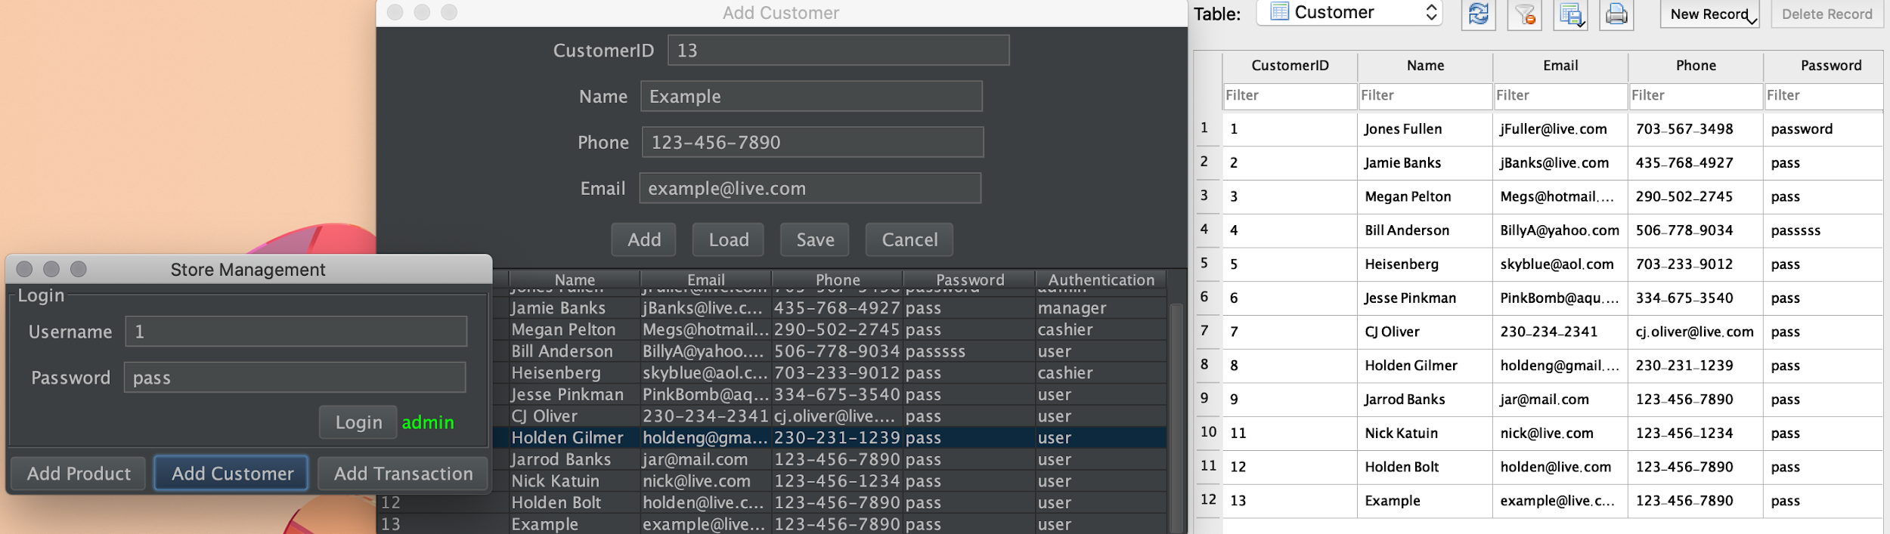

- As an admin, I should be able to change the authentication of any user in the case of a promotion/demotion.(Here user ID 3 Megan Pelton was promoted from cashier to manager)

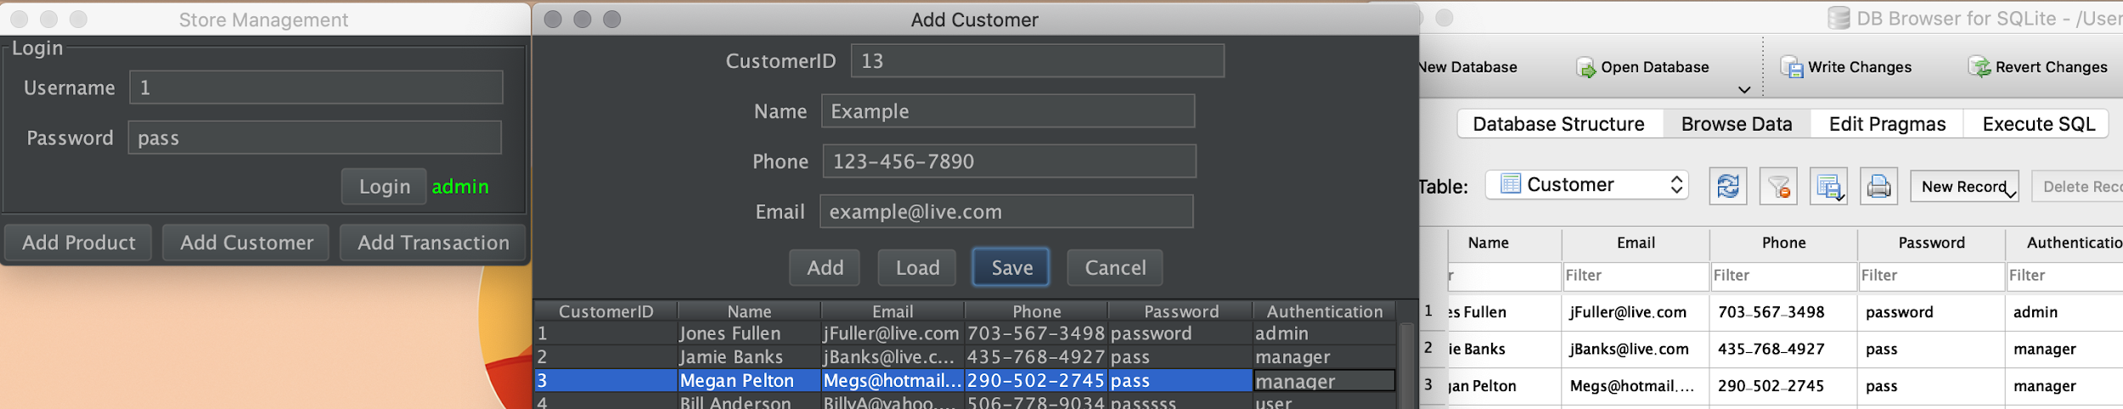

## MANAGER STORIES ##

- As a manager, I should be able to add new products and edit existing ones in the product tab. (Here, a manager adds item “New Item” and edits “Beer”(id 12) to “Beer Edit”)

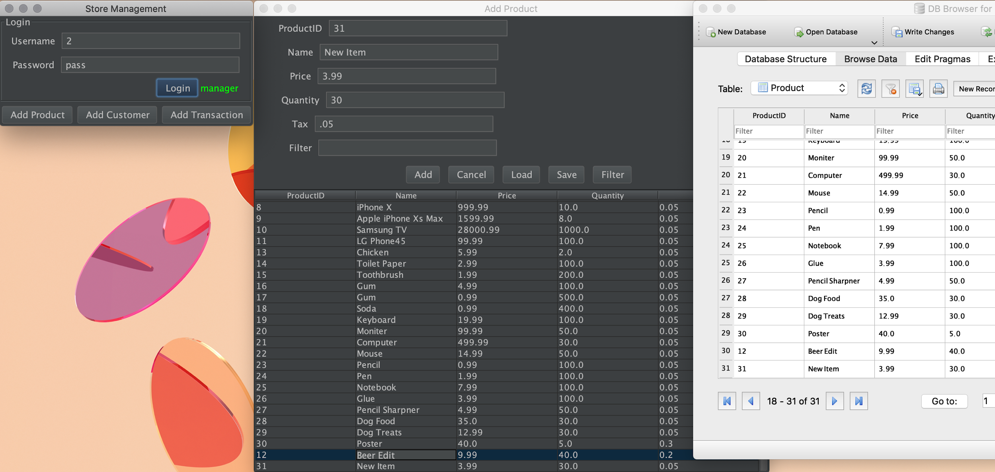

- As a manager, I want to login and be able to view a summary report of sales from the system when I hit print receipt.(Here a manager logs in, heads over to the transaction menu and selects print. Then a terminal will display the transaction as well as the total revenue collected from them all, in this case its 25258.74$).

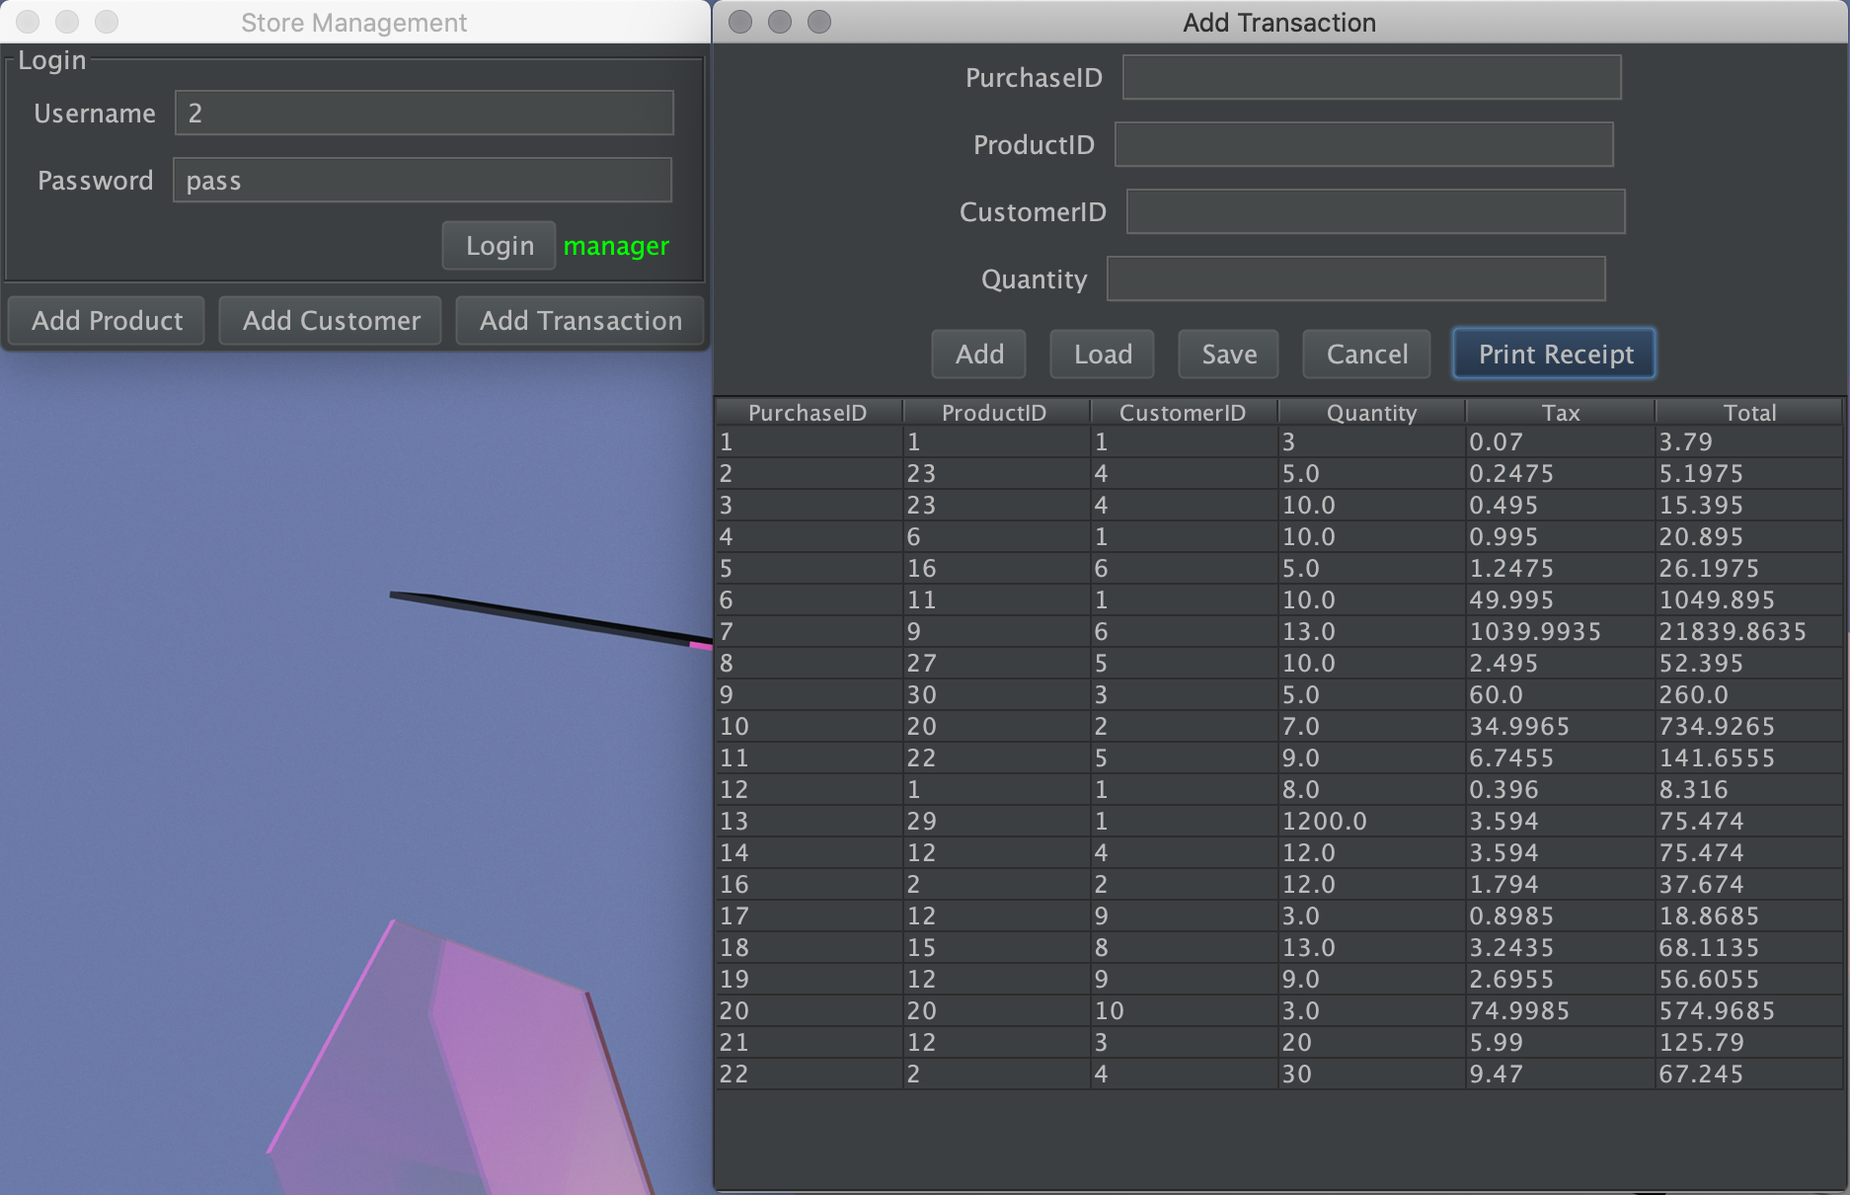

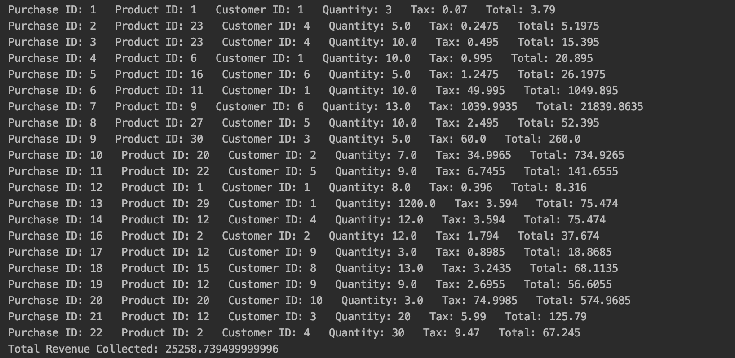

## CASHIER STORIES ##

- As a cashier, I want to add a new customer or update a current customer in the system.(Here a cashier can only see part of the list, this is cause cashiers can only view other users and themselves. Customer “test” with ID 13 is added and Customer 12 Holden Bolt had his name changes to Holden Polt)

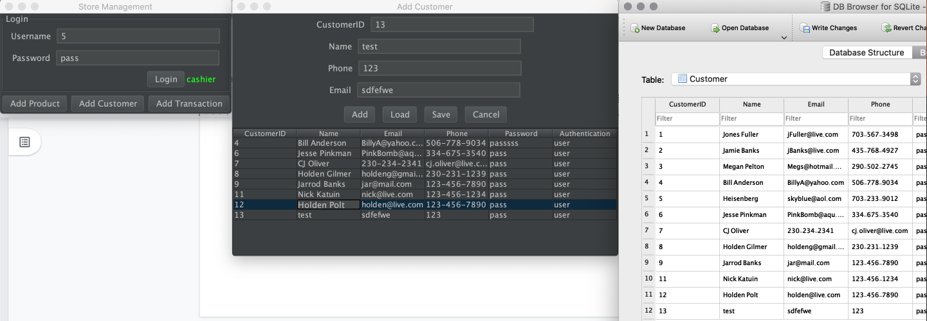

- As a cashier, I want to add a new purchase or update a current purchase (only price and quantity) in the system.(Here a cashier adds a new purchase with ID 21, and edits a mistake in transaction 20 from price 1574.9685 to 574.9685 after hitting save)

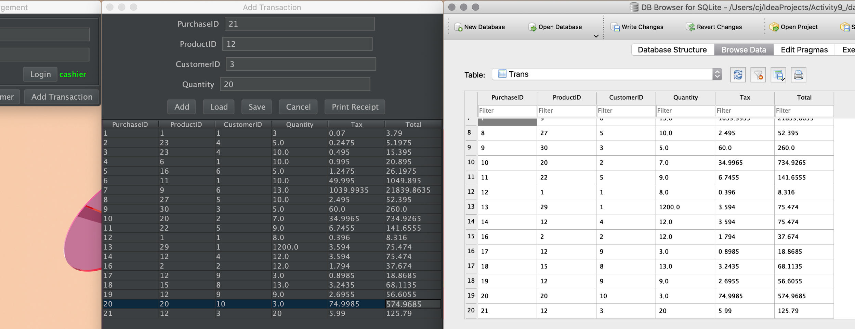

## CUSTOMER STORIES ##

- As a customer, I want to add a new purchase into the system.

- As a customer, I want to view my purchase history into the system.

When a customer logs in and goes to the transaction tab, they will only be able to view their own transaction and add new ones to it. (Here, customer Bill Anderson can only see transaction with customer ID 4, and has made a new transaction with purchase ID 22)

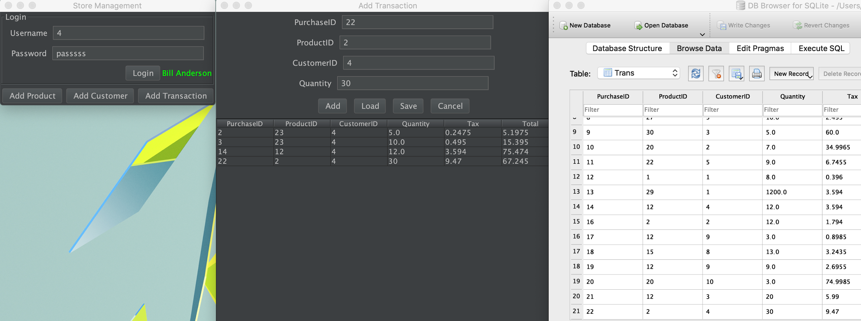

- As a customer, I want to search for product information (based on name, price) in the system.(Here customer Bill types in 3.99 into the filter box and selects filter button, then the table updates to the 3 items in the inventory matching the price namely Hamburger, Glue, and the test item “New Item”

